**Topics: Normal distribution, Functions of Random Variables**

1. The time required for servicing transmissions is normally distributed with *μ* = 45 minutes and *σ* = 8 minutes. The service manager plans to have work begin on the transmission of a customer’s car 10 minutes after the car is dropped off and the customer is told that the car will be ready within 1 hour from drop-off. What is the probability that the service manager cannot meet his commitment?
2. 0.3875
3. 0.2676
4. 0.5
5. 0.6987

**Ans.**

Time taken for service transmission= T

T is normally distributed with *μ* = 45 minutes and standard deviation *σ* = 8 minutes.

Time delay= 10 minutes

Time available to finish the work= 60-10=50 minutes.

Therefore from the equation Z=(T-µ)/ *σ*

P(T≤50)=p(Z≤(50-45)/8)=p(Z≤0.625)= 0.7324(using z table)

Therefore p(T>50)=1-p(≤50)= 1-0.7324= 0.2676

(Or)

Using Python-function :

**from scipy import stats**

**1-stats.norm.cdf(50,loc=45,scale=8)**

**0.26598552904870054**

**Hence option B is correct answer.**

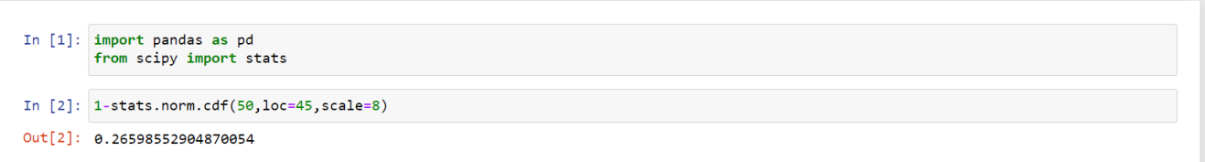

1. The current age (in years) of 400 clerical employees at an insurance claims processing center is normally distributed with mean *μ* = 38 and Standard deviation *σ* =6. For each statement below, please specify True/False. If false, briefly explain why.
2. More employees at the processing center are older than 44 than between 38 and 44.
3. A training program for employees under the age of 30 at the center would be expected to attract about 36 employees.

Ans.

1. **False:**

Employees at the processing center of 44 age is 0.84134 ~ 84.13%

stats.norm.cdf(44,loc=38,scale=6)

Employees at the processing center of 38 age is 0.5 ~ 50%

stats.norm.cdf(38,loc=38,scale=6)

Hence People between 38 & 44  age = 84.13 - 50 = 34.13 % ≈  137 out of 400

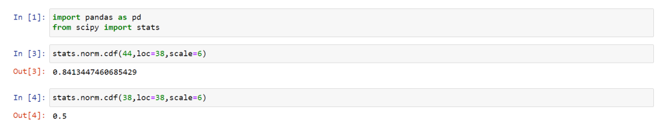

Hence More employees at the processing center are older than 44 than between 38 and 44. This statement is F**ALSE.**

**B) True:**

A training program for employees at the age of 30 is 0.0912 ~ 9.12%

stats.norm.cdf(30,loc=38,scale=6)

As about 9.12% of employs comes under age 30 and also out of 400 if we consider 9.12 % it will be 36 persons out of 400.

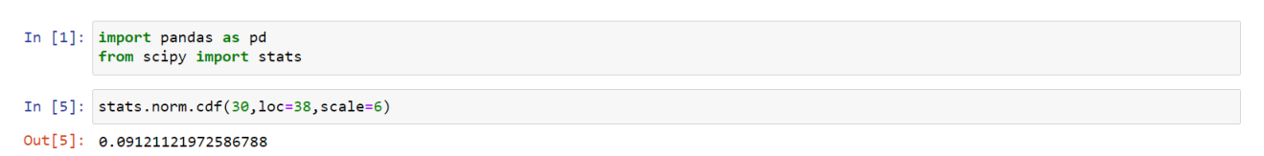

Hence training program for employees under the age of 30 at the center would be expected to attract about 36 employees - **TRUE**

1. If *X1* ~ *N*(μ, σ2) and *X*2 ~ *N*(μ, σ2) are *iid* normal random variables, then what is the difference between 2 *X*1 and *X*1 + *X*2? Discuss both their distributions and parameters.

Ans)

2 $X_{1}$ is simply a larger scale version of the random variable *X1.* If $X_{1}$ is normally

distributed then 2X1 is also normally distributed.

In 2X1 : 2X1~N(2µ,4σ²) normally distributed with mean 2*mean(X) = 2µ and variance var(2*X1) = 4*var(X1) = 4σ²

*X*1 and *X*2 are normal distributed, the associated sums and random samples are exactly

(and not just approximately) normal, with the appropriate parameters.

In X1+X2 : X1+X2~N(2µ,2σ²) normally distributed with mean mean(X)+ mean(Y) = µ+µ = 2µ and variance σ²+σ² = 2σ².

1. Let X ~ N(100, 202). Find two values, *a* and *b*, symmetric about the mean, such that the probability of the random variable taking a value between them is 0.99.
2. 90.5, 105.9
3. 80.2, 119.8
4. 22, 78
5. 48.5, 151.5
6. 90.1, 109.9

Ans. z = x-µ /σ says that x=σ[z] + µ

Mean is 100 and Standard deviation is 20 alpha is 0.005

Z value of 0.995 is 2.57

Thus "a" = 0.5th percentile for X = 20[-2.57] + 100 = 48.5

and "b" = 99.5th percentile for X = 20[+2.57] + 100 = 151.5

Hence option D is correct answer.

1. Consider a company that has two different divisions. The annual profits from the two divisions are independent and have distributions Profit1 ~ N(5, 32) and Profit2 ~ N(7, 42) respectively. Both the profits are in $ Million. Answer the following questions about the total profit of the company in Rupees. Assume that $1 = Rs. 45
2. Specify a Rupee range (centered on the mean) such that it contains 95% probability for the annual profit of the company.

Ans)

Total profit of the company =( Profit 1 + Profit 2 ) ~N((5+7),(3 2 +4 )) =N(12,25)

Here we want to find Rupee range (centered on the mean) such that it contains 95% probability for the annual profit of the company. Total area under the normal curve is 1.

Therefore excluded area is 1-0.95 = 0.05 excluded area is 0.025 in each of the left and right tails of the normal curve.

Thus, we want to find the 2.5 th and 97.5 th percentiles.

To find the 2.5 th percentile value of profit we have to find Z .025 =-1.96

To find the 97.5 th percentile value of profit we have to find Z .975 =1.96

Therefore lower rupee range = X= (-1.96*5 )+12=2.2$ =2.2*45=99 rs

upper rupee range = X= (1.96*5 )+12 =21.8 $ =21.8*45 =981 rs

1. Specify the 5th percentile of profit (in Rupees) for the company

Ans)

To find the 5 th percentile value of profit we have to find Z α =Z 0.05

= - 1.644584

Therefore 5 th percentile value of profit =( -1.644584 * 5) +12 =3.777 $

=3.777*45 =170 rs

1. Which of the two divisions has a larger probability of making a loss in a given year?

Ans)

Division 2

Probability of making loss means that there is a 0 profit.

Z value for first division is Z= = -5/3 = -1.667

Z value for Second division is Z= = -7/4 = -1.75

Since second division has the least value of Z, it has smaller probability of making loss.